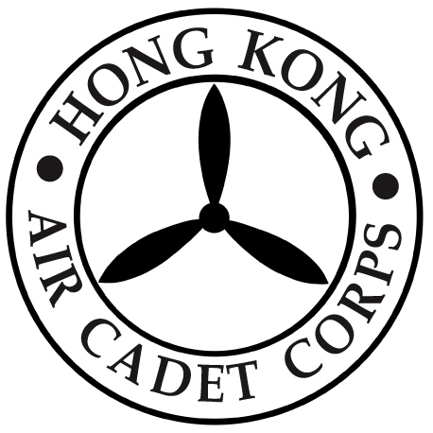

HONG KONG AIR CADET CORPS

From : HQ  Ref : GR20_008 | To : Unit Commanders  Cc : Major Unit Commanders
Tel : 2712 8900  Fax : 2715 6944 | Date: 26 June 2020

Closure of WHQ Office

Please be informed that due to improvement work, the WHQ office will be closed with effect from Monday, 29 June 2020 until further notice. Room reservation service at WHQ office is also suspended accordingly.

Should you have any enquiry, please contact WHQ Manager by email (hq_wgoffice@aircadets.org.hk), alternatively you are also welcome to contact Headquarters staff at 2712 8900.

Megan TIN
Administrative Manager

